NAME – AKASH KUMAR PATI

**SIMPLILEARN PHASE-2 PROJECT**

**FLY AWAY**

**PROJECT DESCRIPTION**

Tech Stack Used:

1. JAVA
2. HIBERNATE
3. SERVLETS

Server Used:

Tomcat Version 8.5

**FLOW CHART**

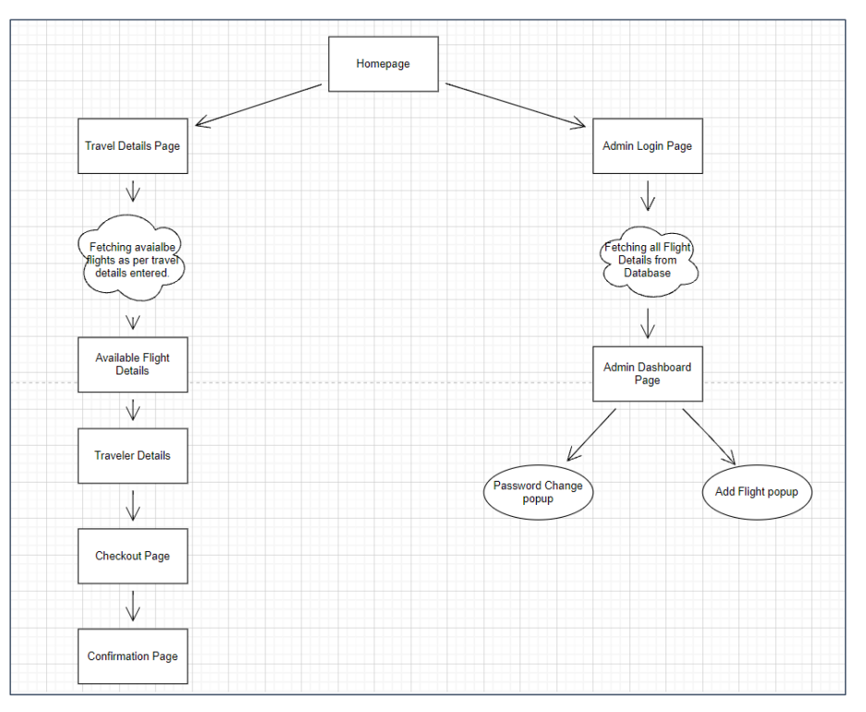

**PROJECT USER STORIES**

1. As a developer, I want to build register/login functionality.
2. As a developer, I want to allow user to view flights as per preference.
3. As a developer, I want to allow admin to add/modify flight related information
4. As a developer, I want the user to be able to successfully view flight prices and names as per preference
5. As a developer, I want the user to be able to book a flight via a payment gateway
6. As a developer, I want the payment gateway to be authenticated properly to prevent any flaws in the transaction process
7. As a user, I want to book a flight securely, with proper amount deductions from my account, post the booking process

**Sprint 1**

1. As a developer, I want to build register/login functionality.
2. As a developer, I want to allow user to view flights as per preference.
3. As a developer, I want to allow admin to add/modify flight related information

**Sprint 2**

1. As a developer, I want the user to be able to successfully view flight prices and names as per preference
2. As a developer, I want the user to be able to book a flight via a payment gateway
3. As a developer, I want the payment gateway to be authenticated properly to prevent any flaws in the transaction process

**Sprint 3**

1. As a user, I want to book a flight securely, with proper amount deductions from my account, post the booking process

**PROJECT GITHUB REPOSITORY**

Link : https://github.com/234akash/phase2_project_FlyAway.git

**How to Run Project**

1. Clone Project

Clone git : <https://github.com/234akash/phase2_project_FlyAway.git>

Right click on the project 🡪 Run on Server 🡪 and execute the code.

**Outputs:**

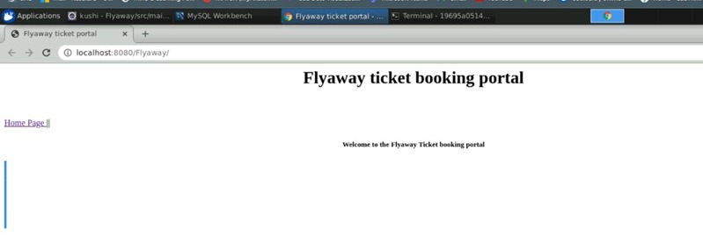

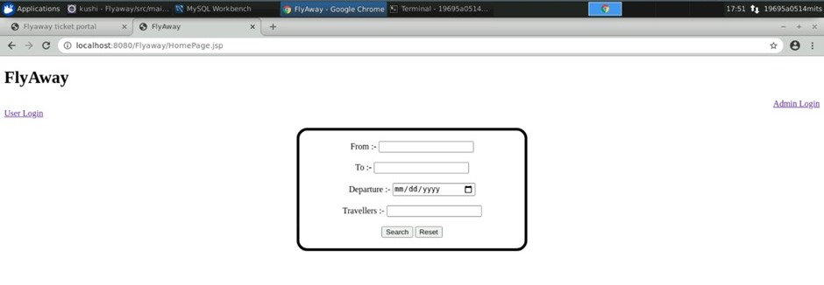

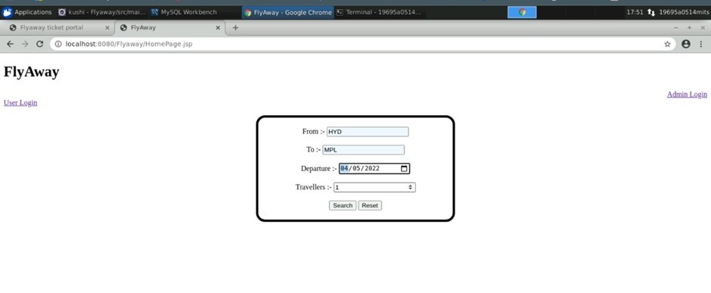

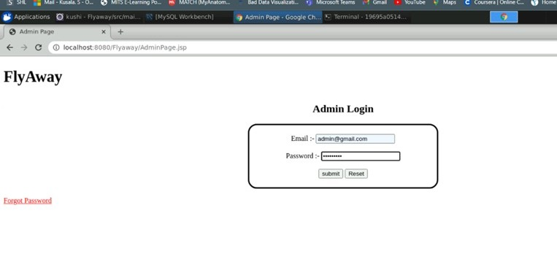

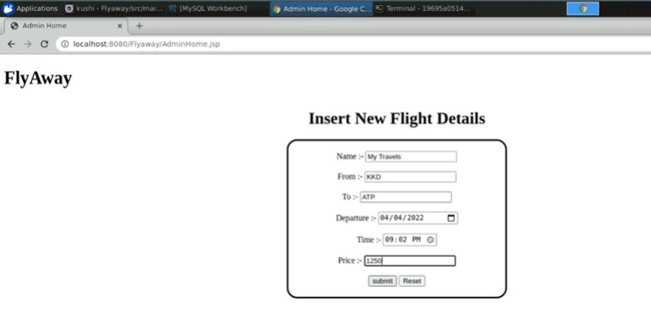

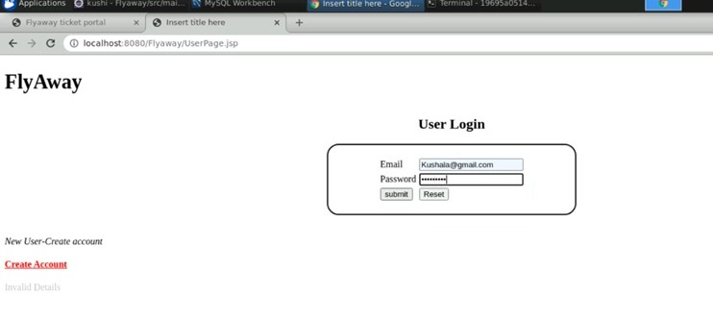

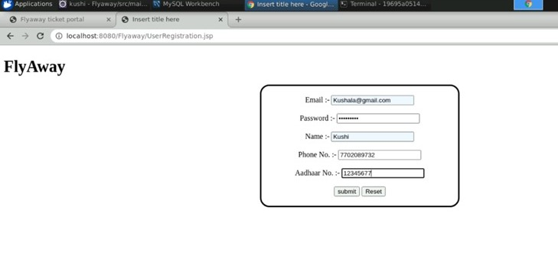

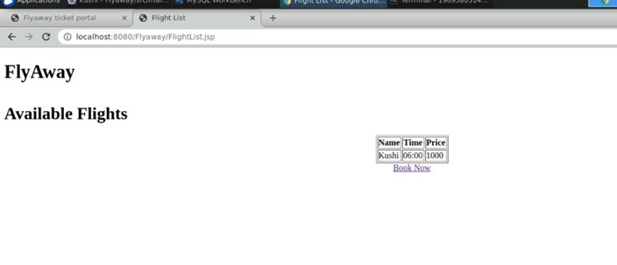

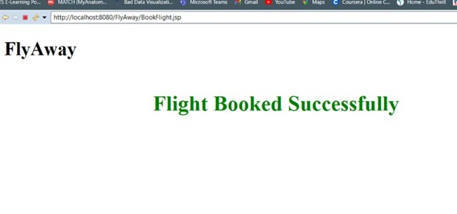

***=====================END===============================***